**Creating Microservices for account and loan**

**Account Microservice:**

**Steps:**

1. Go to: https://start.spring.io

* Group: com.cognizant
* Artifact: account
* Dependencies:
  + Spring Web
  + Spring Boot DevTools

1. Download and open the project in STS4.
2. Create controller class (AccountController.java)

package com.cognizant.account.controller;

import org.springframework.web.bind.annotation.GetMapping;

import org.springframework.web.bind.annotation.PathVariable;

import org.springframework.web.bind.annotation.RequestMapping;

import org.springframework.web.bind.annotation.RestController;

import java.util.Map;

@RestController

@RequestMapping("/accounts")

public class AccountController {

@GetMapping("/{number}")

public Map<String, Object> getAccount(@PathVariable String number) {

return Map.of("number", number, "type", "savings", "balance", 234343);

}

}

1. Run the application as Spring Boot App.

**Output:**

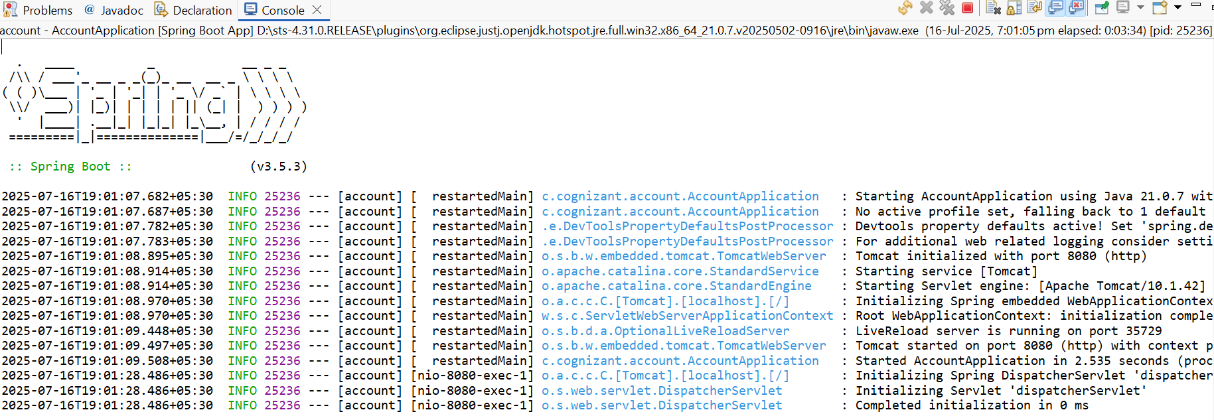

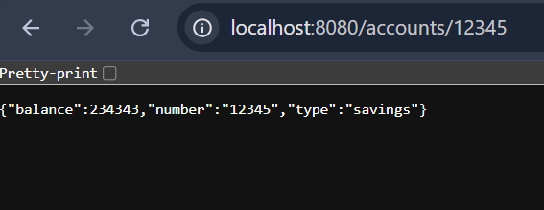

**Loan Microservice:**

**Steps:**

1. Go to: https://start.spring.io

* Group: com.cognizant
* Artifact: loan
* Dependencies:
  + Spring Web
  + Spring Boot DevTools

1. Download and open the project in STS4.
2. Set different port in src/main/resources/application.properties

spring.application.name=loan

server.port=8081

1. Create controller class (LoanController.java).

package com.cognizant.loan.controller;

import java.util.Map;

import org.springframework.web.bind.annotation.GetMapping;

import org.springframework.web.bind.annotation.PathVariable;

import org.springframework.web.bind.annotation.RequestMapping;

import org.springframework.web.bind.annotation.RestController;

@RestController

@RequestMapping("/loans")

public class LoanController {

@GetMapping("/{number}")

public Map<String, Object> getLoan(@PathVariable String number) {

return Map.of("number", number, "type", "car", "loan", 400000, "emi", 3258, "tenure", 18);

}

}

1. Run the application as Spring Boot App.

**Output:**

